***Day 4: Pandas Basics Assignment (Himanshu Chadha B- 42)***

## Section A: Fill in the Blanks

1. pd.DataFrame(…) creates a DataFrame
2. df.head(n) shows the first n rows of the DataFrame.
3. df.shape returns a tuple (rows, columns)
4. df.columns lists the column names.
5. df.dtypes shows each column’s data type.
6. To compute summary stats like sum or mean → df.sum ( ) or df.mean() individually.
7. df.groupby('col') first groups the rows by the values in col.
8. After grouping, .agg({'col':'sum'}) aggregates the values in that column.

## Section B: Match the Columns

1. df.head() → d. Shows the first few rows
2. df.dropna() → a. Removes rows with missing values
3. df.columns → b. Shows column names
4. df.agg() → c. Computes summary statistics
5. df.groupby('col') → f. Splits the DataFrame into groups
6. df.dtypes → e. Shows data type of each column

## 

## Section C: True / False

1. df.shape returns (rows, columns). → True
2. df.tail() shows the first 5 rows by default. → False (it shows the last 5 rows)
3. After df.groupby('city'), you can call .agg() to summarize. → True
4. df.fillna(0) removes rows with missing values. → False (it fills missing with 0)
5. df.describe() gives count, mean, min, max for numeric columns. → True
6. df.info() shows row count, column names, and data types. → True

## Section D: Short Answer

1. What is a DataFrame?  
    A DataFrame is a 2D, tabular data structure in pandas with labeled rows and columns.
2. Why do we use df.head() before any analysis?  
    It helps preview the first few rows to quickly understand structure and spot issues.
3. Explain why checking df.dtypes is important.  
   Because correct data types ensure accurate operations and prevent errors in analysis.
4. How does df.groupby() help when you have categories?  
   It groups rows based on categories, allowing category-wise summaries or aggregations.
5. When would you use df.agg() instead of individual .sum() or .mean() calls?  
   When we need multiple aggregations (e.g., sum, mean, min, max) at once on different columns.

Section E: Practical Coding (Real-Life Scenarios)

E1: Weekly Milk Sales

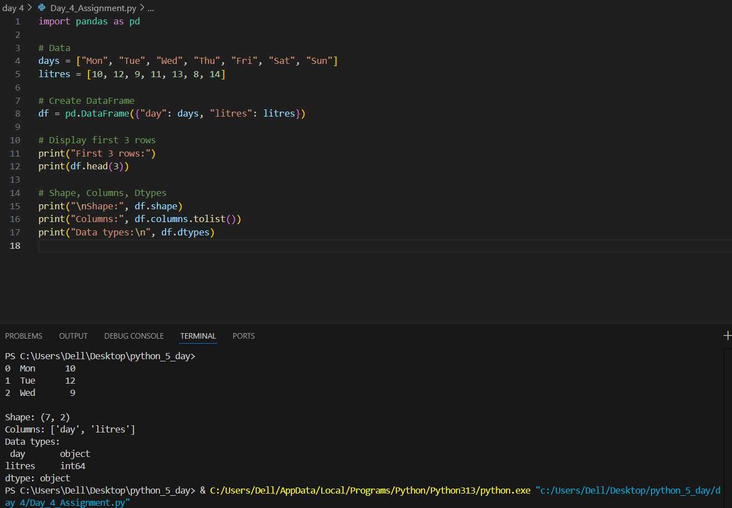

E2: Monthly Expenses Summary

